BASIC INFO PAGE
Put Title Text Field before First Name Text Field: Create these dropdowns for the Title Text Field: Prof,. Dr., Mr., Mrs., Miss, Master, Ms, Dr., Other
- Already completed
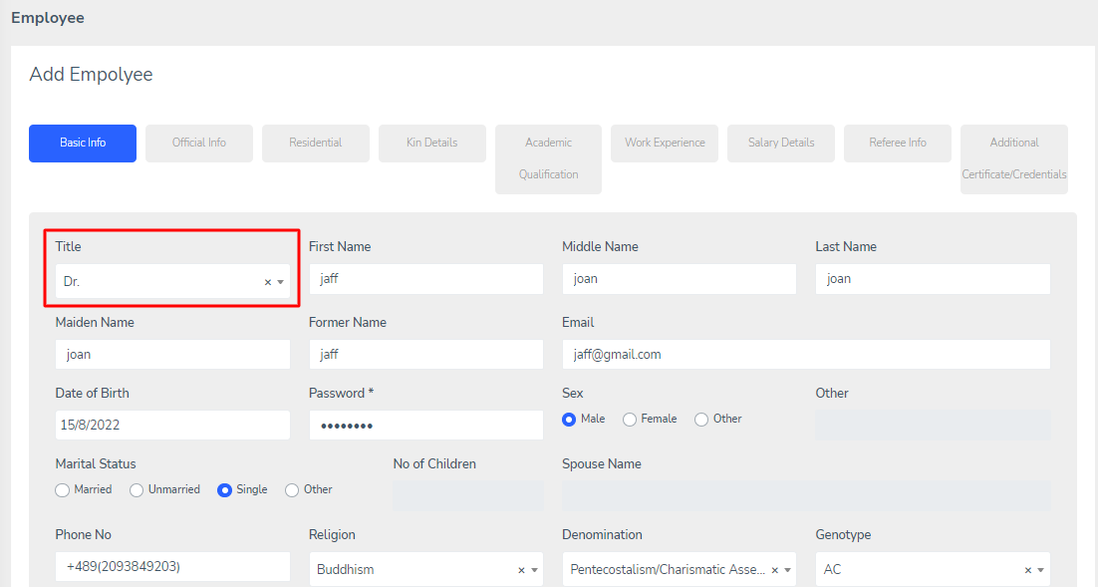
Atfer the Last Name Text Field: Maiden Name Text Field, Former Name Text Field
- Already completed
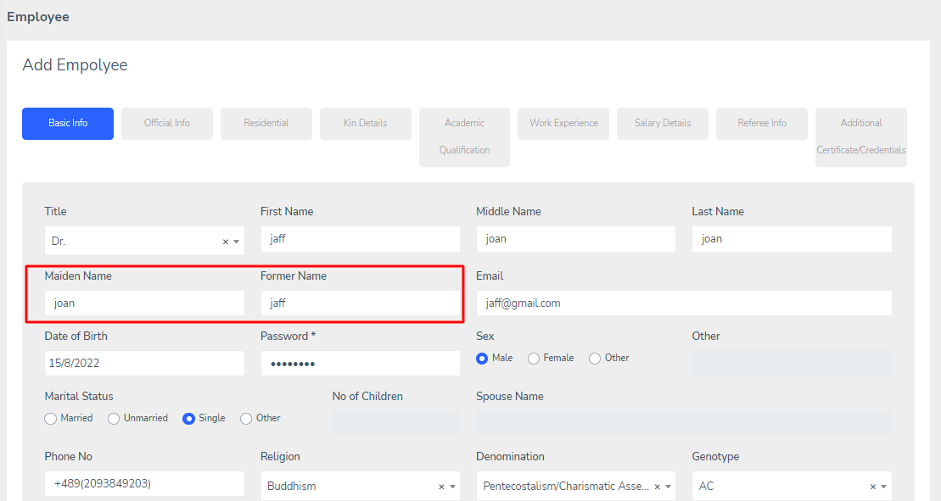
Follow this Order: Religion, Denomination, Genotype, Blood Group, Country, Nationality and so on
- Already completed
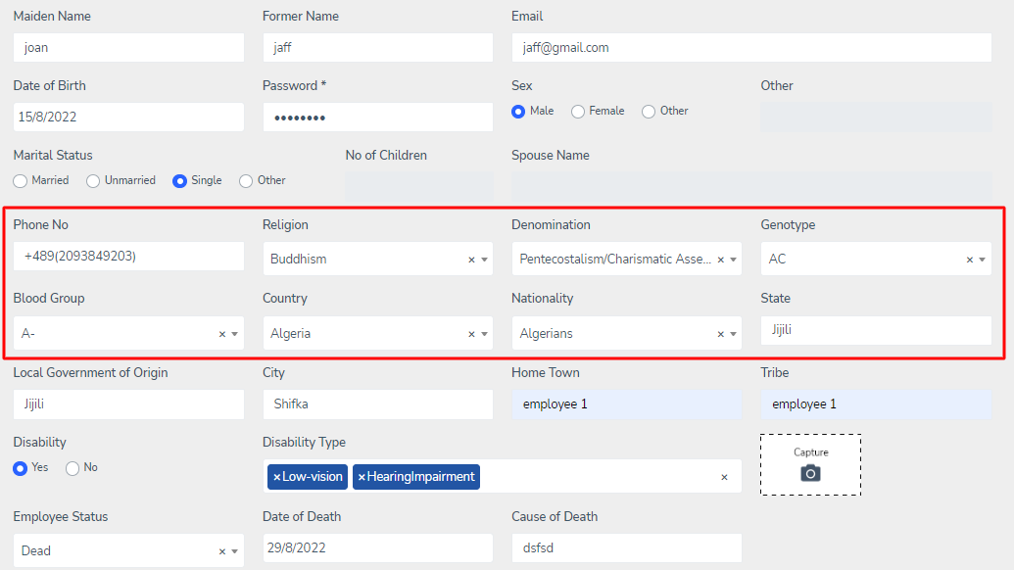
Change Home Twon to Home Town
- Already completed
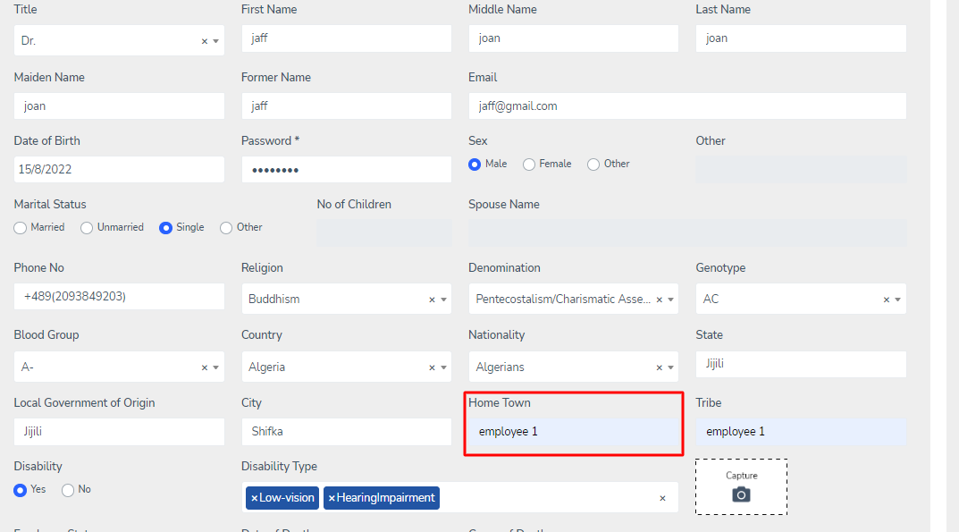
Change Date Format to: Day/Month/Year
- Already completed
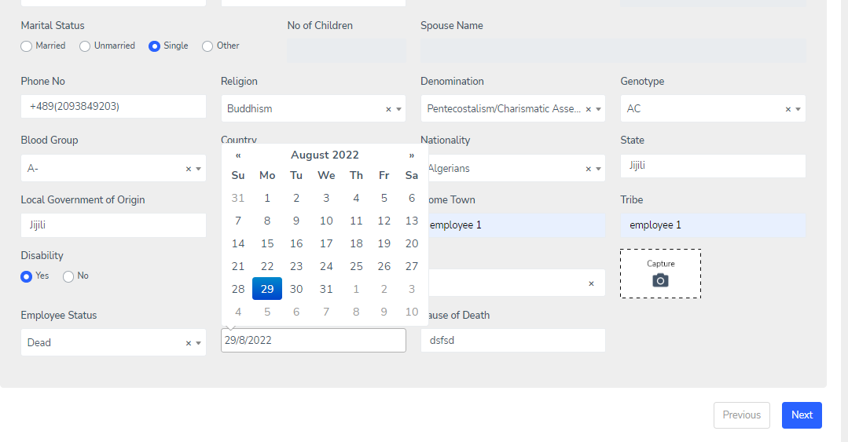
When Unmarried is Selected Under Marital Status the No of Children Text Field Should be Activate for Entry
- Already completed
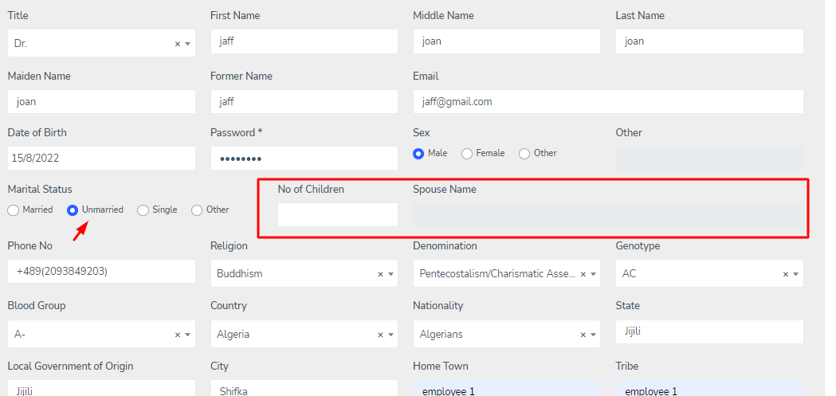
State and Local Governement Areas Dropdowns not Popping down
-
The Dropdowns for State and Local Government Area Should be replicate for all other State and LGA Text Fields on all the Registration Pages
- Already completed
Put: Any Form of Disability? Yes or No Radio Button
- Already completed
- On progress
Put Disability Types Dropdowns With Checkboxes for More Than One Disability
- Already completed
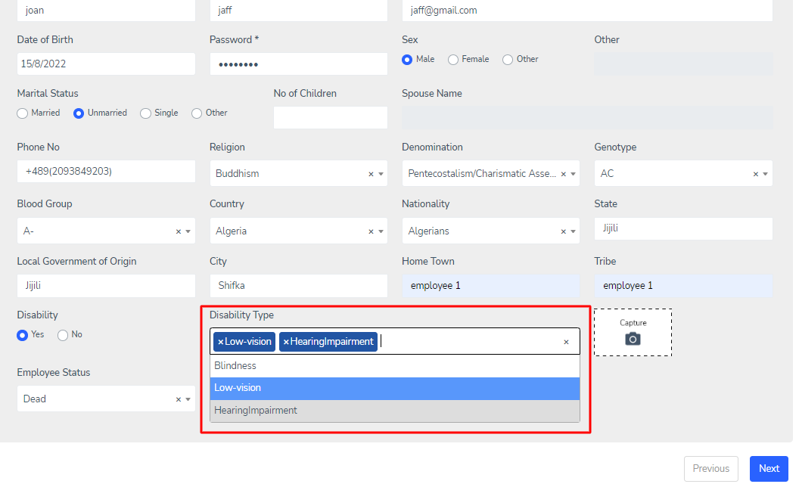
Signature Specimen and FingerPrint near the Image Capture Button
-
Put Employee Status Dead or Alive
- Already completed
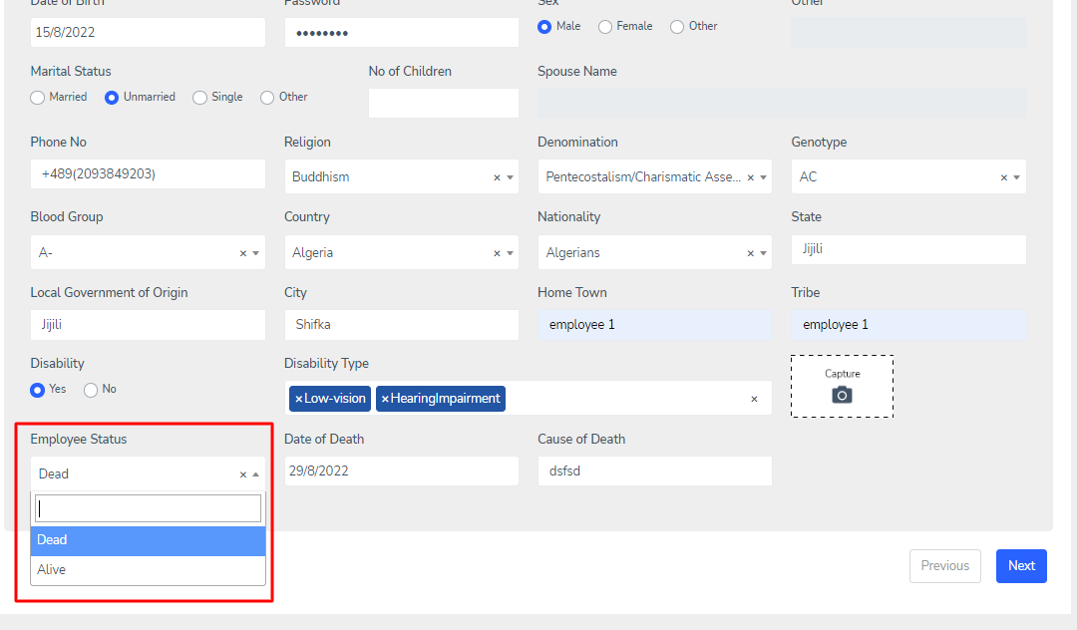
If Dead: Date of Death, Cause of Death, View Service History
- Completed,
Just one thing that in service history button we will give link after we create the History module.

CLICK ON EMPLOYEE REGISTARTION NUMBER ON THE EMPLOYEE LIST TO GENERATE EMPLOYEE ID CARD
For this can you provide us the size of the ID card and details, what kind of details you want to show in the ID CARD?

OFFICIAL INFO PAGE
Change Desiganation to Designation
- Done
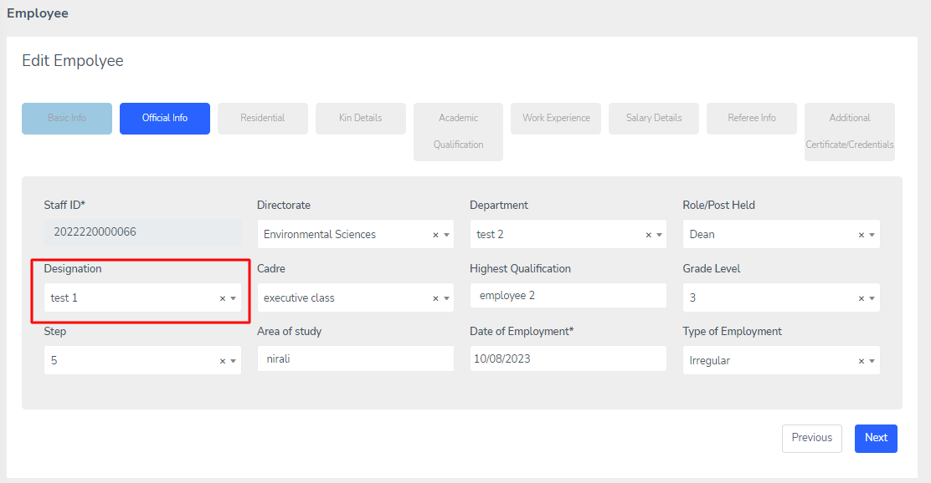
Cadre: Put Dropdowns in all Cadre Text Fields on the Form
- Already completed
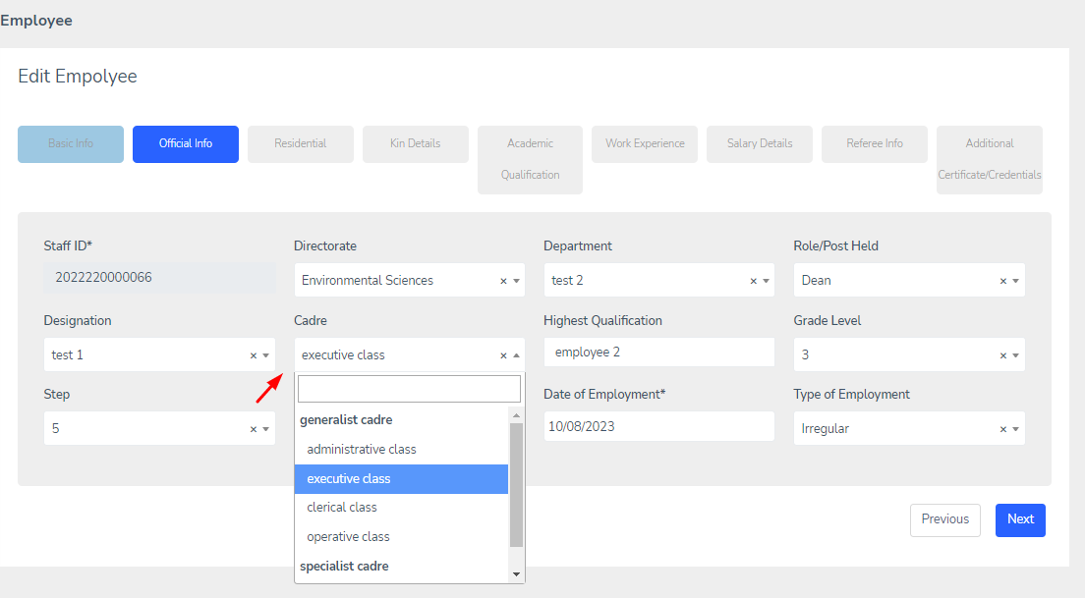

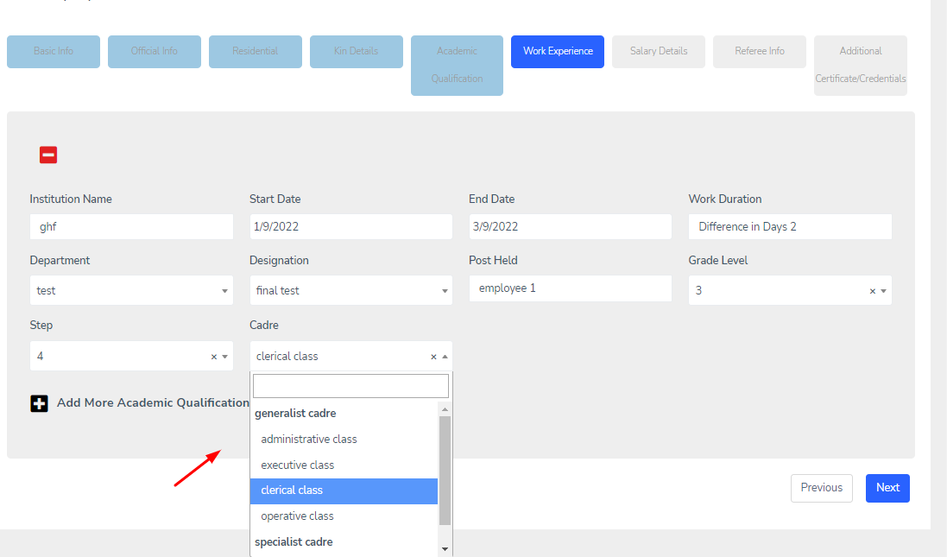
RESIDENTIAL PAGE
Dropdowns for State and Local Government Area
- Already completed
KIN DETAILS PAGE
Ok

ACADEMIC QUALIFICATION PAGE
Change Certificate Obtained to Certificate/Honours Obtained
- Already completed
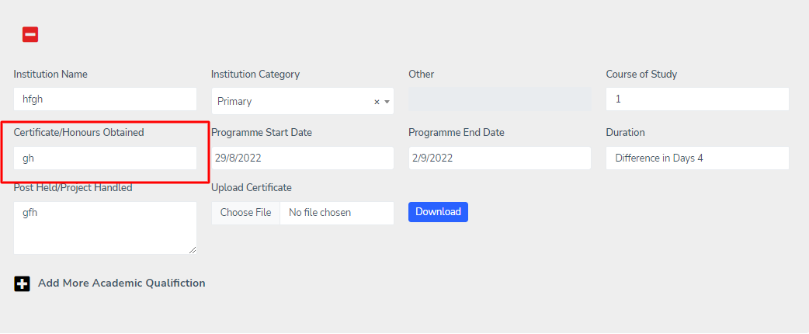
Change Programme Duration Start Date To .... Programme Start Date
- Already completed
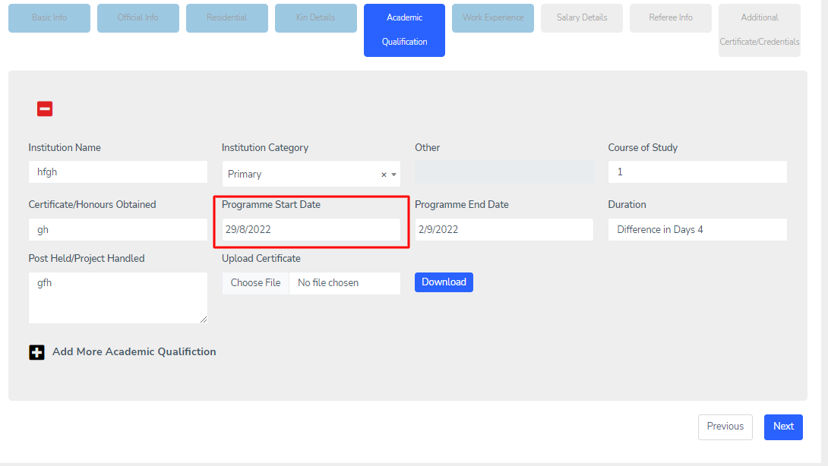
Change Programme Duration End Date To .... Programme End Date
- Already completed
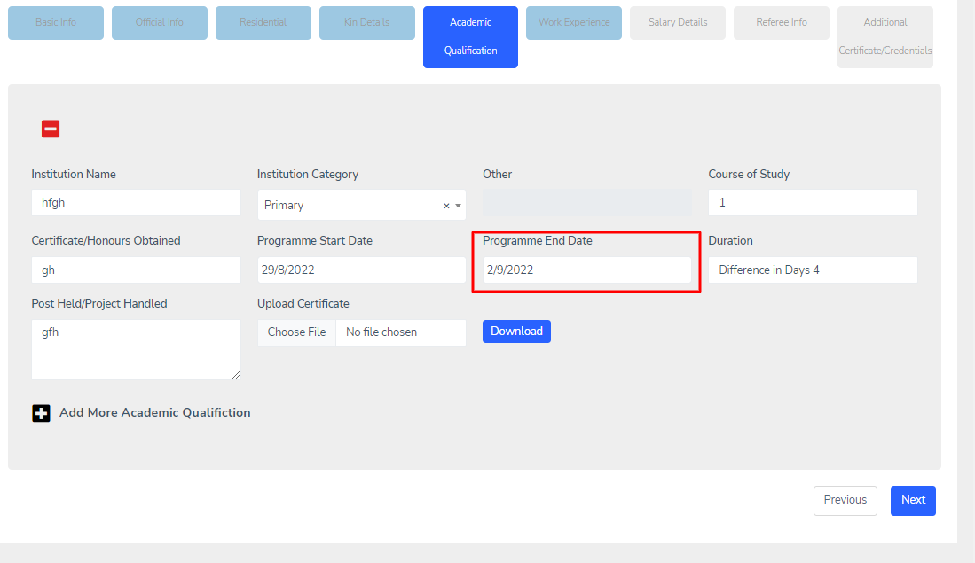
Immediately After the Programme End State put Duration Text Field
- Already completed
Duration(Day(s)/Month(s)/Year(s) = Programme End Date - Programme Start Date
- Completed
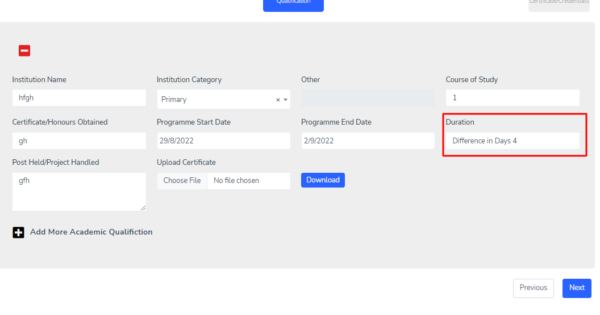
Experience/Project Handled Text Field Not Required Again
Replace Experience/Project Handled Text Field with Duration Text Field
- Already completed
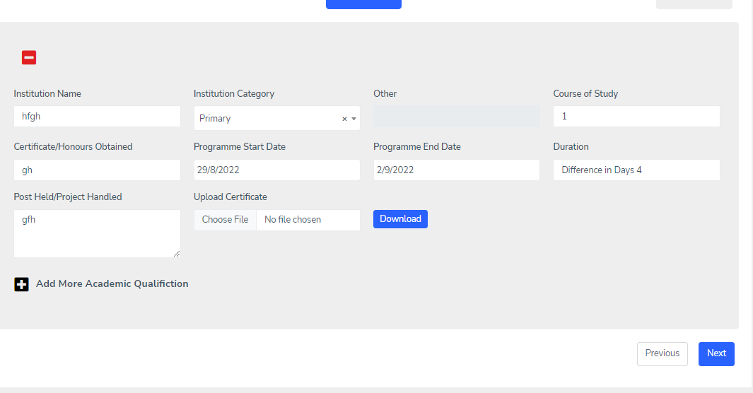
Put Upload Certificate Button
- Already completed
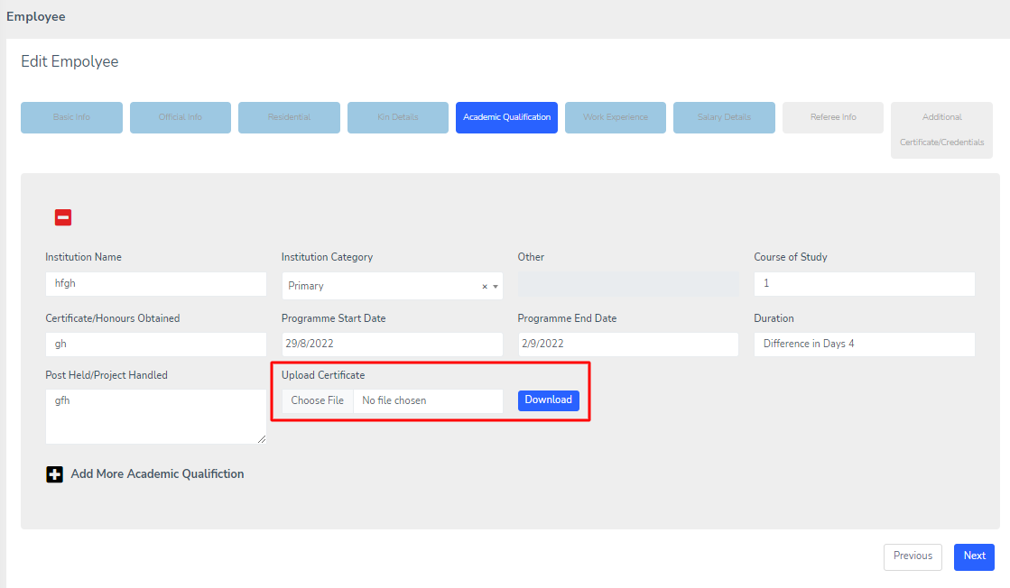
WORK EXPERIENCE PAGE
Break Work Duration Text Field Into Two: Start Date Text Field and End Date Text Field
- Done
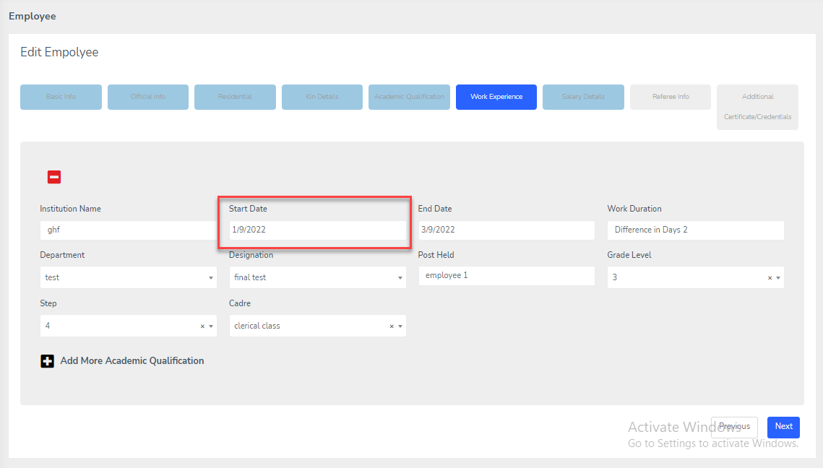
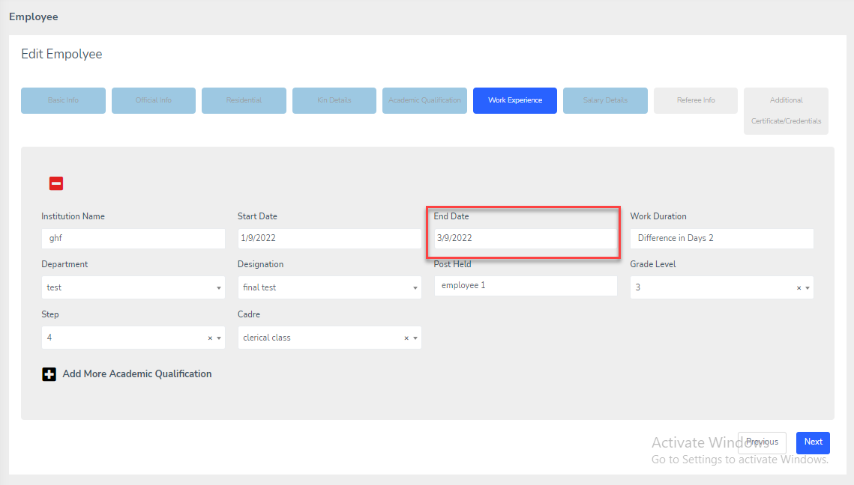
Create Duration Text Field: End Date - Start Date
- Done

Duration Text Field(Day(s)/Month(s)/Year(s)
- Done
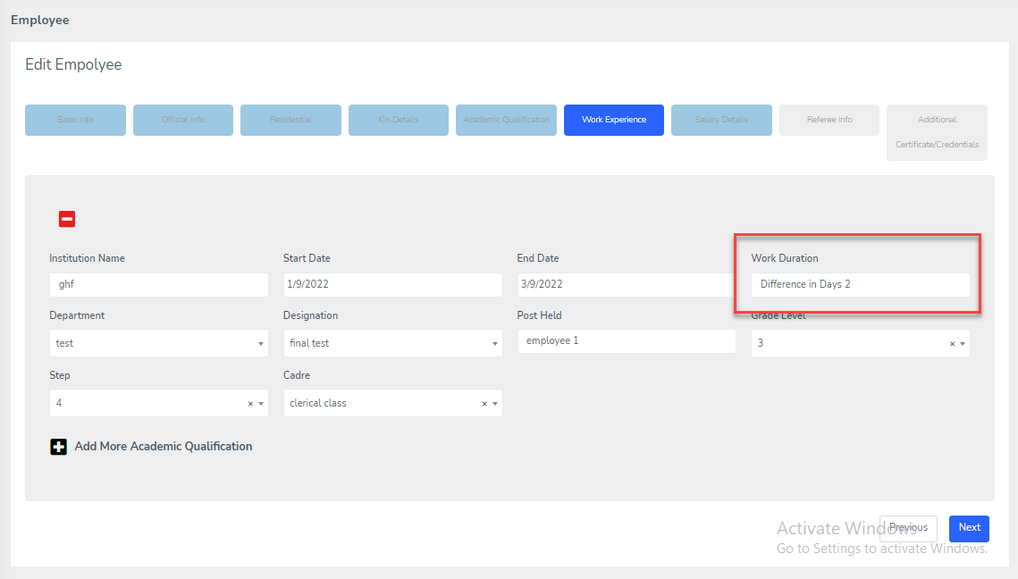
Implement Dropdowns for the Remaining Text Fields
- Done
SALARY DETAILS PAGE
Ok

REFREE INFO PAGE
Ok
ADDITIONAL CERTIFICATE(S)/CREDENTIAL(S) PAGE
Create Additional Certificate/Credentials Page
Create UPLOADS/VIEW/DATE OBTAINED for the Following: Allow for Multiple Uploads for Each:

Birth Certificate
- Already completed
Change of Name Proof
Professional Certificated
- Already completed
Marriage Certificated
- Already completed
Award/Honorary Certificate
- Already completed
Other Certificate(Option to be able to Type In the Certificate Name to Upload)
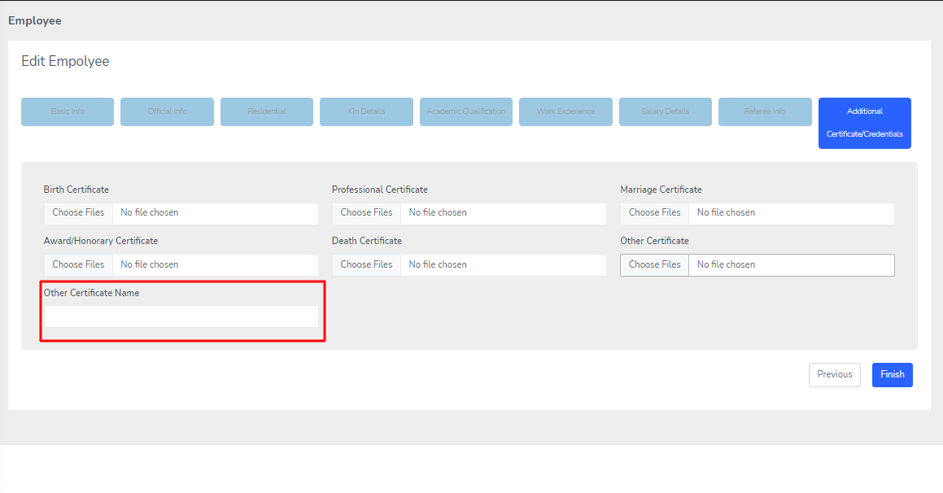
Death Certificate
- Already completed
